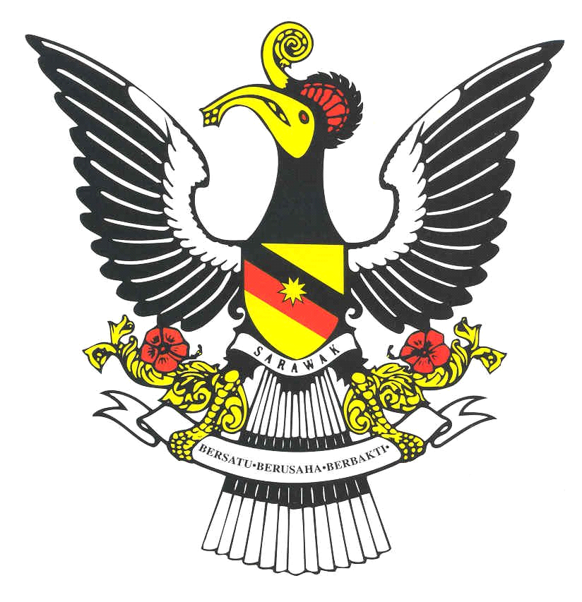
RAINFOREST
WORLD PUPPET CARNIVAL
*3 to 10 November 2019 * Sarawak – Borneo, Malaysia*
Facebook: PuppetCarnival Fest Email: puppetcarnival@gmail.com
www.WorldPuppetCarnival.com

Support Puppet Arts! It's Good for Humanity!
INVITATION TO PARTICIPATE
Dear Puppeteers:
World Puppet Carnival with the Ministry of Culture and Tourism of Malaysia and the state of Sarawak invite you to participate in the spectacular “Rainforest World Puppet Carnival” in Sarawak, Borneo from 3 to 10 November 2019. The best Puppet productions (theatre, video and film) from all over the world will be selected to perform on the exotic and amazing island of Borneo.
Rainforest Carnival showcases Borneo's diversity of ethnic races, cultures and puppets together with an amazing mix of attractions. You will see the most beautiful Wilderness, Rainforest, Beaches and unspoiled Nature in the World. Your experience will fill you with glorious memories to follow you throughout your lifetime.
You are invited to present your show, video, or film; for children, family or adults, to meet Artists from around the world and to share with them your talent and craft.

Your program can be traditional, classic, innovative or experimental, for theatres or for the street. All groups, duos, and solo performers with big spectacles or small performances are encouraged to apply.

The Rainforest World Puppet Carnival is a competition. Valuable prizes with Gran Prix Award will be awarded by an Intercontinental Jury. The Prize categories include Best Animation, Best Actor, Best Actress, Best Director, Best Scenery, Best Puppet Design, Best Film, Best Video, Best Children Performance, Best Original Performance, Best Traditional Performance, Best Artistic Creation and Gran Prix for the Best Carnival Performance.
Participants at the Rainforest World Puppet Carnival will be provided with accommodation, meals, local transportation and daily pocket money.
You are kindly asked to choose one of your performances, film or video and send electronically as a file with completed Application form and 5 photos by email before 1 March 2019.

The Carnival Director will announce selected Performances, Films and Video until 15 March 2019.

You need to send :

- Completed Application Form

- Video file of your show, Video or Film

- 5 photos of the Show, Film or Video

- A short Summary –story- of the Show, Film or Video

Please send all these material by email to:

PuppetCarnival@gmail.com

Rainforest World Puppet Carnival welcomes Puppeteers from all over the World to meet in the most beautiful and exotic Place in the World, where the Ocean Kisses the Jungle.
If you need more information regarding Carnival, please contact us via website: www.WorldPuppetCarnival.com

by email: PuppetCarnival@gmail.com or phone:

+420608203601

10 December 2018 Rainforest World Puppet Carnival
Rod Petrovic Artistic Director
